TAXES MADE EASIER

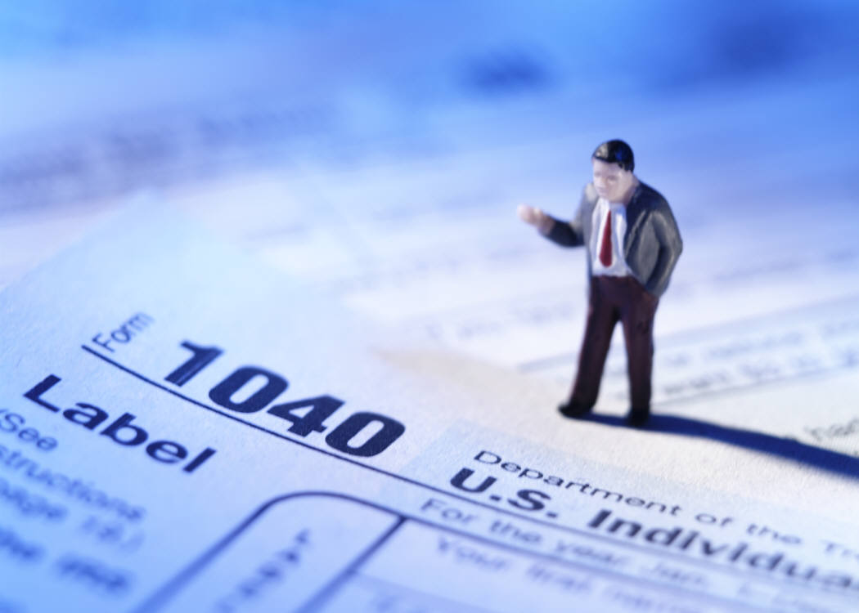
NEEDHAM PUBLIC LIBRARY

Community Room

Tuesday Feb. 27, 2007

7:00 PM to 8:30 PM

FREE Seminar

NEED A BETTER UNDERSTANDING
OF YOUR TAXES? THIS IS YOUR CHANCE!

PRESENTED BY: KIMBERLY J. HOWARD, CFP ®
KJH FINANCIAL SERVICES
NEEDHAM, MA
781.413.4879

